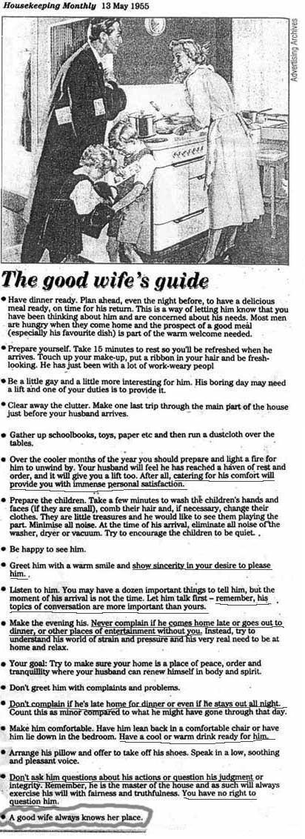
Discussion Questions:
What is the purpose of this article?

What is the main idea of this article?

How does this article reflect a specific point of view?

How have cultural norms changed since this article was published?

In what ways have cultural norms stayed the same?

